VISVESVARAYA TECHNOLOGICAL UNIVERSITY

## Jnana Sangama, Belagavi - 590018



**Project Report on**

“RESOURCE BOOKING AND MANAGEMENT”

Submitted in partial fulfillment of the requirements for the award of the degree of

# BACHELOR OF ENGINEERING

**in**

# COMPUTER SCIENCE & ENGINEERING

## By

|  |  |
| --- | --- |
| **HEGDE SUMANTH SHYAM** | **4MT20CS073** |
| **JANI KALIANPUR** | **4MT20CS076** |
| **MELAN VARGHESE** | **4MT20CS097** |
| **MUHAMMED AFNAN HANIF** | **4MT20CS104** |
| **NANDANA KEVEES** | **4MT20CS106** |



### DEPARTMENT OF COMPUTERSCIENCE & ENGINEERING

***(Accredited by NBA)***

# MANGALORE INSTITUTE OF TECHNOLOGY & ENGINEERING

*Accredited by NAAC with A+ Grade, An ISO 9001: 2015 Certified Institution* (*A Unit of Rajalaxmi Education Trust®, Mangalore - 575001*) Affiliated to VTU, Belagavi, Approved by AICTE, New Delhi

Badaga Mijar, Moodabidri-574225, Karnataka

**2022-23**

# ABSTRACT

This project report details the development of a comprehensive Resource Booking and Management system tailored for educational institutes and colleges. The primary aim of this system is to provide an efficient and centralized platform for managing and booking various resources, including labs, auditoriums, and training centers. By leveraging a user-friendly interface, the system empowers administrators to oversee resource allocation effectively, while coordinators can seamlessly book and manage resources for a wide range of events and activities.

The core objective of the Resource Booking and Management system is to eliminate the challenges posed by manual resource booking processes and disjointed coordination efforts. The system's benefits include streamlining resource utilization, reducing conflicts and double bookings, and optimizing the overall efficiency of resource management within the institution. With real-time visibility into resource availability and bookings, the system enhances collaboration between administrators and coordinators, fostering better organization and utilization of resources.

**INTRODUCTION**

In modern educational institutions, managing and booking resources like labs, auditoriums, and training centers can be a complex and time-consuming task. The Resource Booking and Management system aim to address these challenges by providing an automated and centralized platform for resource management. This system will greatly simplify the process of resource booking and coordination for both administrators and coordinators, enhancing the overall efficiency of resource utilization within the institute.

**Problem Statement:**

The current resource management process at our educational institute relies on manual booking systems, which often leads to conflicts, double bookings, and inefficient resource utilization. Coordinators face difficulty in finding available resources, while administrators struggle to maintain an accurate overview of resource usage. This project seeks to overcome these limitations by developing a robust Resource Booking and Management system that offers real-time resource availability and facilitates seamless coordination between administrators and coordinators.

**Summary**:

Resource Booking and Management system provides an efficient and centralized platform for managing and booking various resources, including labs, auditoriums, and training centers. By leveraging a user-friendly interface, the system empowers administrators to oversee resource allocation effectively, while coordinators can seamlessly book and manage resources for a wide range of events and activities. The core objective of the Resource Booking and Management system is to eliminate the challenges posed by manual resource booking processes and disjointed coordination efforts. The system's benefits include streamlining resource utilization, reducing conflicts and double bookings, and optimizing the overall efficiency of resource management within the institution. With real-time visibility into resource availability and bookings, the system enhances collaboration between administrators and coordinators, fostering better organization and utilization of resources.

**FUNCTIONAL REQUIREMENTS**

1. **Admin Panel:**
   * Ability to add, edit, and delete resources (labs, auditoriums, training centers) with their relevant details.
   * Capability to manage coordinators, including adding new coordinators and modifying their access permissions.
   * View detailed information about resources and event bookings.
2. **Coordinator Panel:**
   * Ability to view the availability of resources for a specific date and time.
   * Capability to book resources for events, lectures, workshops, etc.
   * Access to view event details, including event date, time, purpose, and related information.
3. **Resource Booking and Scheduling:**
   * Ensure prevention of double bookings and conflicts.
   * Allow coordinators to schedule recurring bookings if necessary.
4. **User Authentication and Authorization:**
   * Secure login system to authenticate users and assign appropriate roles and permissions.
5. **Notifications:**
   * Send email or in-app notifications to users for resource booking confirmations and updates.
6. **Reporting and Analytics:**
   * Generate reports on resource utilization and popular booking times for data analysis.
7. **Mobile Responsiveness:**
   * Ensure the system is accessible and responsive on various devices.

**SYSTEM DESIGN**

The Resource Booking and Management system follow a client-server architecture, where the client is a web-based user interface, and the server hosts the core application and database. The system is built using a three-tier architecture, comprising the presentation layer, application layer, and data layer.

The presentation layer consists of a user-friendly web application accessible by administrators and coordinators. The application layer handles the logic for resource booking, event management, and authentication. The data layer includes a relational database to store resource information, booking details, and user profiles.

To ensure scalability and maintainability, the system utilizes the latest web technologies and follows the Model-View-Controller (MVC) design pattern. The front-end is developed using HTML, CSS, JavaScript, and AJAX, while the back-end logic is implemented using a modern programming language like JSP, JDBC. The database management system used is MySQL.

**DOCUMENTATION**

**Mind Map:**

A mind map is a visual representation of ideas, concepts, or information. It is a diagram that helps organize and visually represent the connections between different elements or topics. In a mind map, the central idea or main topic is placed at the center of the diagram, and related subtopics branch out from it, forming a hierarchical and interconnected structure

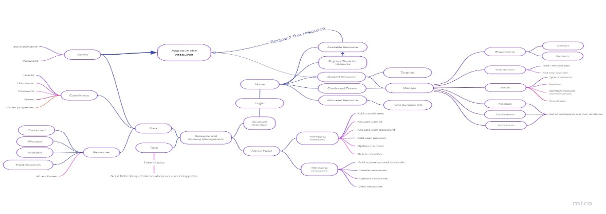

**Schema Diagram:**

A schema diagram, also known as an entity-relationship diagram (ERD), is a visual representation of the logical structure of a database system or data model. It illustrates the relationships between different entities (tables) in the database, along with their attributes (columns). Schema diagrams help in understanding the data organization and how different entities are related to each other.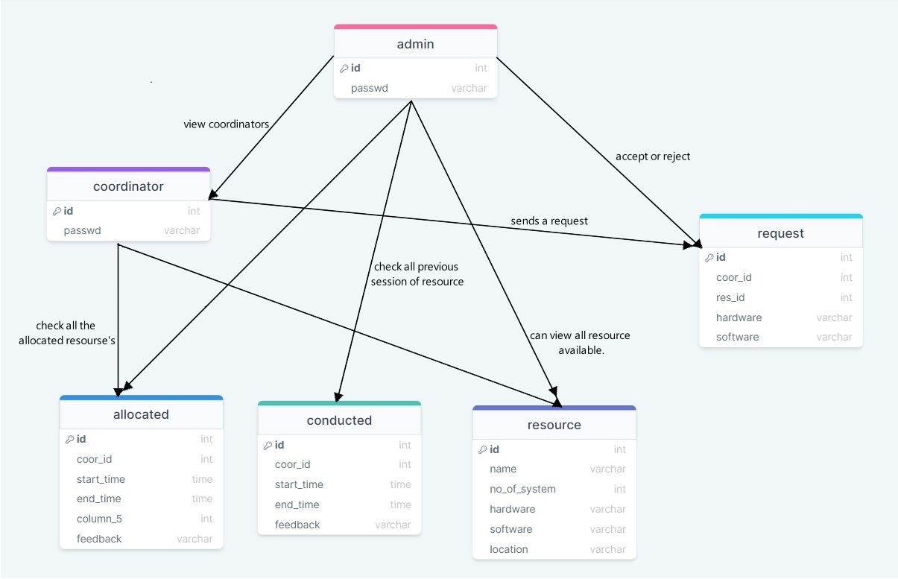

## Functional Requirements:

## Admin:-

1. Resource Panel
   * View available resources
   * View allocated resources
   * View available resources
   * View conducted resources
2. Coordinator Panel
   * View coordinator list
   * Add coordinator
   * Delete coordinator
3. Notifications Panel
   * View Details
   * Fulfil hardware / software requirements
   * Approve request
   * Deny request

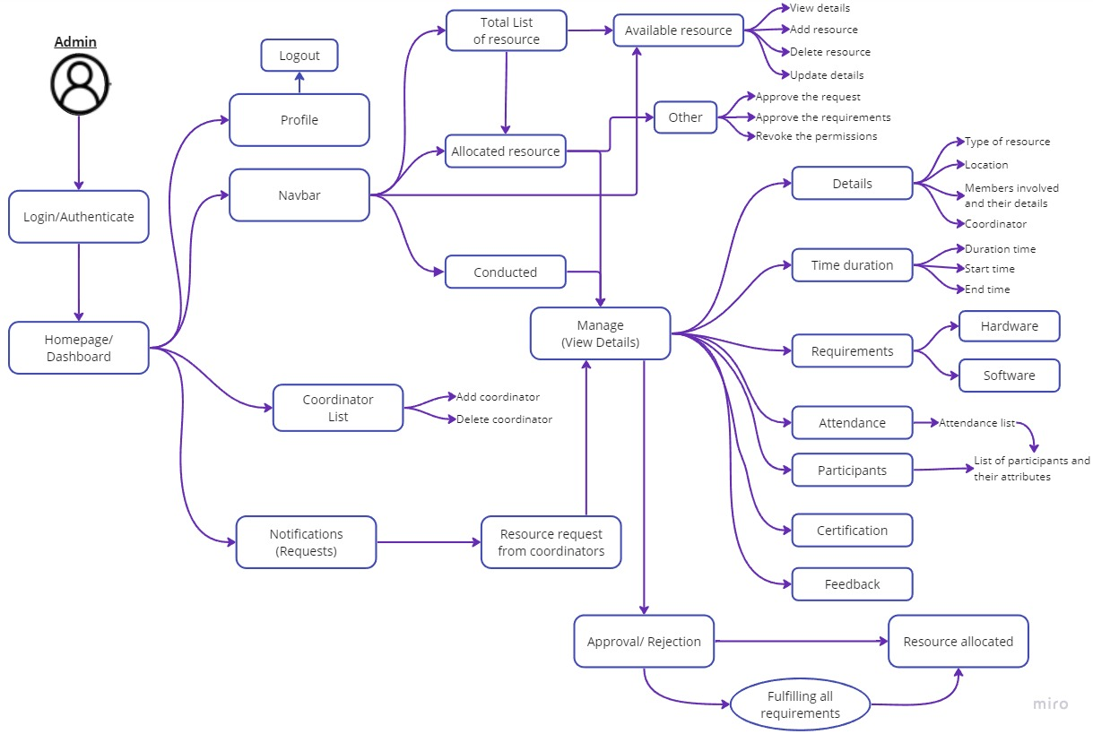

**User:-**

1. View available resources
2. View booked resources
3. View allocated resources
4. View available resources
5. View conducted resources
6. Book resources(Requesting the resource)

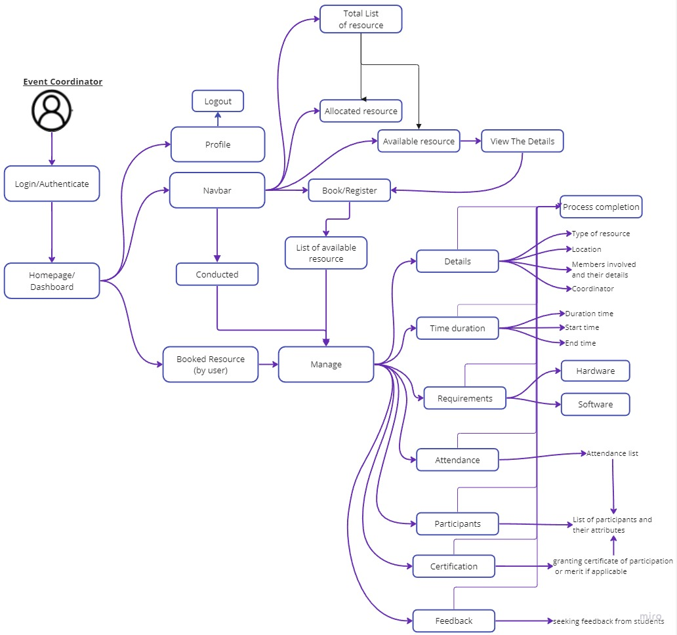

**ARCHITECTURAL DIAGRAM**

## An architectural diagram is a visual representation or schematic that depicts the structure and components of a system or software application. It provides an overview of the system's architecture, including its various modules, components, and their interactions. Architectural diagrams are used to communicate the high-level design and organization of a system to stakeholders, developers, and other team members involved in the project.

## Architectural diagrams typically illustrate the relationships between different components, how they communicate with each other, and the flow of data or information within the system. They often include boxes or rectangles to represent individual components or modules, with lines or arrows indicating the connections and dependencies between them. Additionally, architectural diagrams may include labels, annotations, and descriptions to provide additional context and explanation.

## 

These diagrams serve as a blueprint for designing and implementing complex systems, helping stakeholders understand the overall structure and functionality of the system. They also assist in identifying potential bottlenecks, performance issues, and areas of improvement. Architectural diagrams are crucial in facilitating collaboration, enabling effective communication among team members, and ensuring a shared understanding of the system's architecture and design principles.

# IMPLEMENTATION

## Admin:-

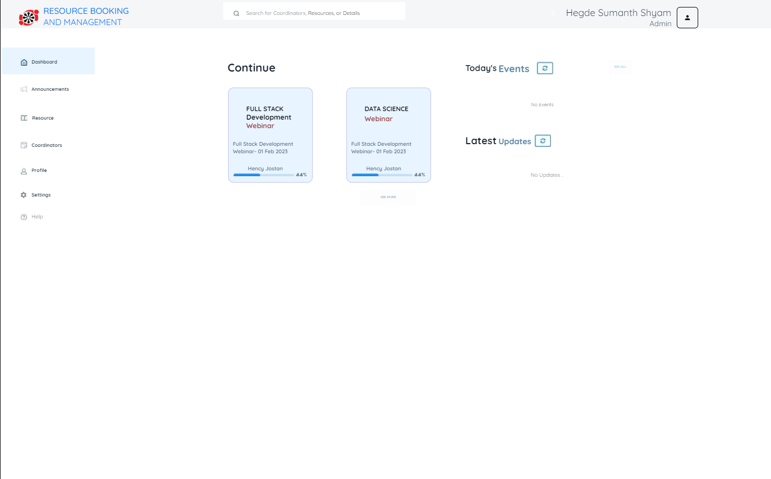

**User:-**

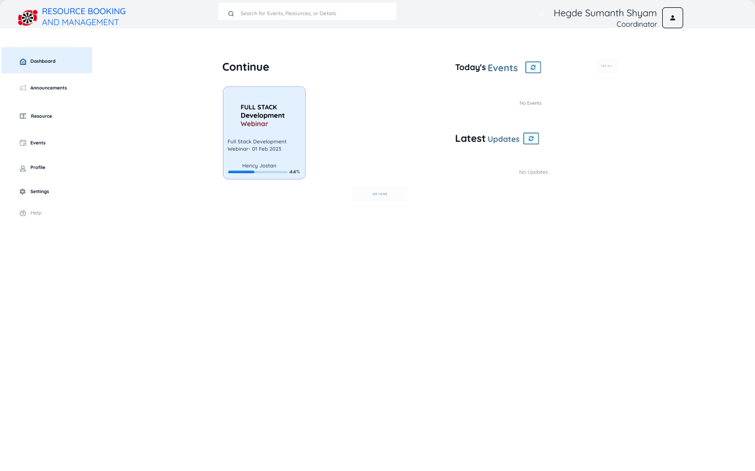

**CONCLUSION**

The development of the Resource Booking and Management system marks a significant advancement in managing resources effectively within our educational institute. The system's implementation has successfully addressed the challenges posed by manual resource booking processes, providing a streamlined and user-friendly platform for administrators and coordinators.

Throughout the development process, we encountered and overcame various technical challenges, such as ensuring data security, preventing conflicts in resource bookings, and designing an intuitive user interface. The adoption of a modular and microservices-based architectural approach has proven beneficial, offering scalability and maintainability.

As a result of this project, resource utilization has improved, and coordinators can now efficiently manage their events without conflicts or overlapping bookings. The system has garnered positive feedback from users during the testing phase, demonstrating its value in enhancing resource management practices.

In conclusion, the Resource Booking and Management system have been successful in achieving its stated objectives. However, we recognize the scope for further enhancements, such as incorporating advanced reporting and analytics, and optimizing resource allocation algorithms. These potential future improvements will further elevate the system's functionality and usability, making it an invaluable asset for our educational institution.